**CS 3343**

Software Engineering Practice

**Group Project – “Hot Meals”**

Group-1

**Installation Guide**

**Group Members**

* Banbah, Kush: 55786740
* Gupta, Aarnav: 55990960
* Jain, Utkarsh: 55992915
* Kasliwal, Aryan Girish: 55972222
* Malhotra, Avi: 55773896
* Rajagopalan, Pratul: 55858290

# Steps for installation

1. To run the system you need the latest version of JRE. Which can be found [here](https://www.oracle.com/java/technologies/downloads/#jdk17-windows). Download according to your OS.

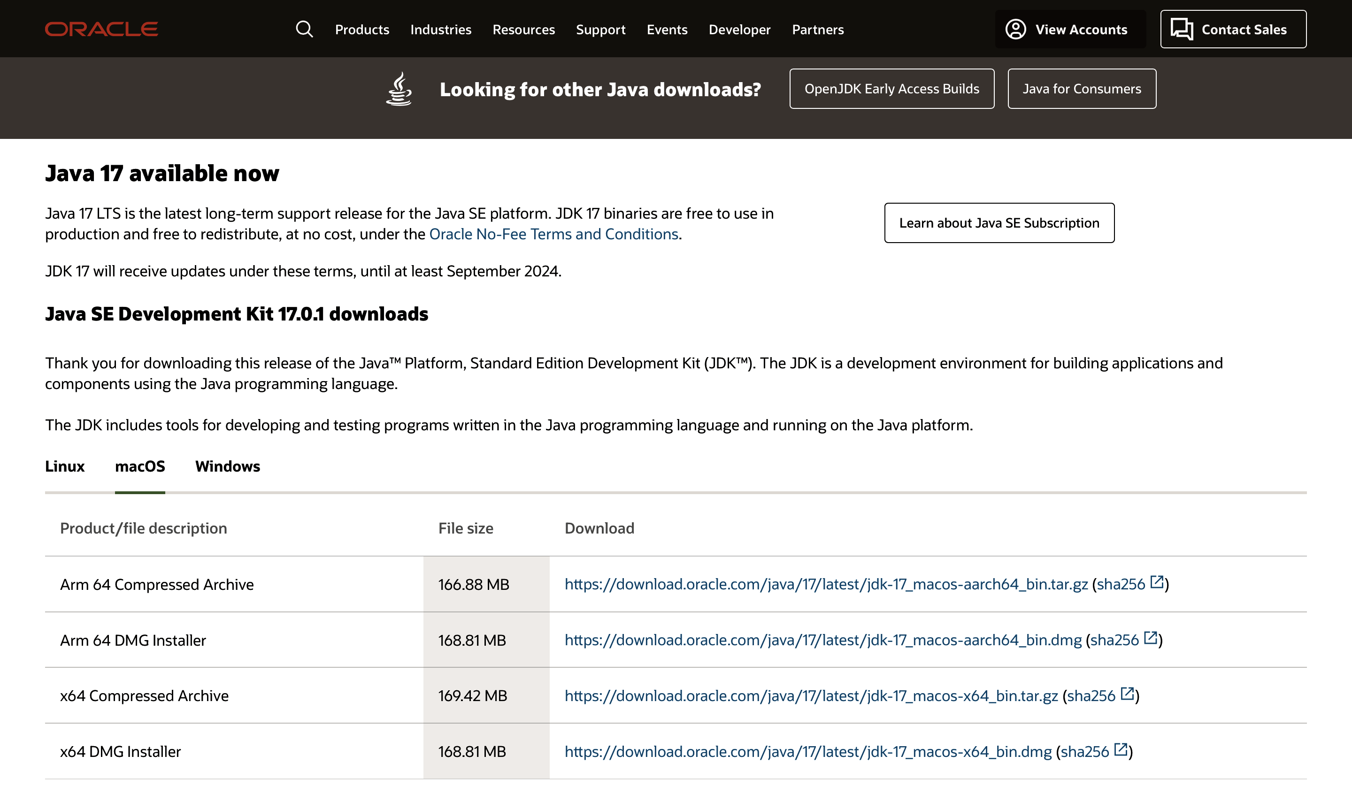

Choose OS accordingly

1. If you are on windows, run the “run.bat” file.
2. If you are on Mac/Linux double click the “run.command” file. If it doesn’t work, drag drop it onto the terminal and press enter.

Please make sure locations.txt and menu.txt are in the same folder or else the program will not work properly!

The other txt files are included for testing!

To run the source code, import all the source code files into an eclipse project and appropriately put all the txt files in the class path. The other txt files (not mentioned above) are used for testing!

# How to use the program

The program allows you to make reservations at restaurants, check and delete them.

Enter 1 to create new booking

Then enter your name

Enter the number of the location

Enter number of people

Enter number for which dishes to order

Select time between the given timeslots!

Once you are directed to payment, if it fails you can enter yes to retry payment or no to exit to menu

A successful booking can be checked by typing 3 from menu for check booking and then entering booking number

Finally, you can also delete a booking by typing 4 and entering booking number

Since we cannot simulate getting current time and waiting all day, you can set the internal time of the system by entering 2 from the menu and entering the amount of minutes to tick forward! For example, ticking the system forward by 60mins will reach 12pm. So no new booking can now be made before 12pm, previous bookings are still visible however.